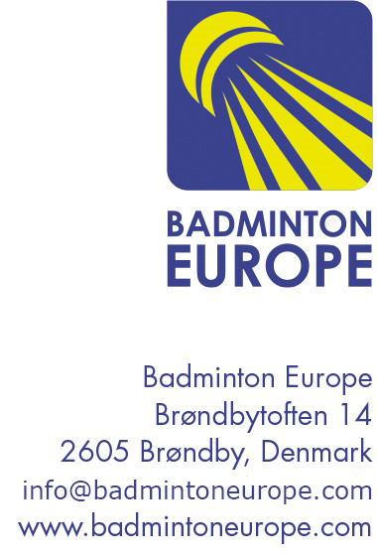
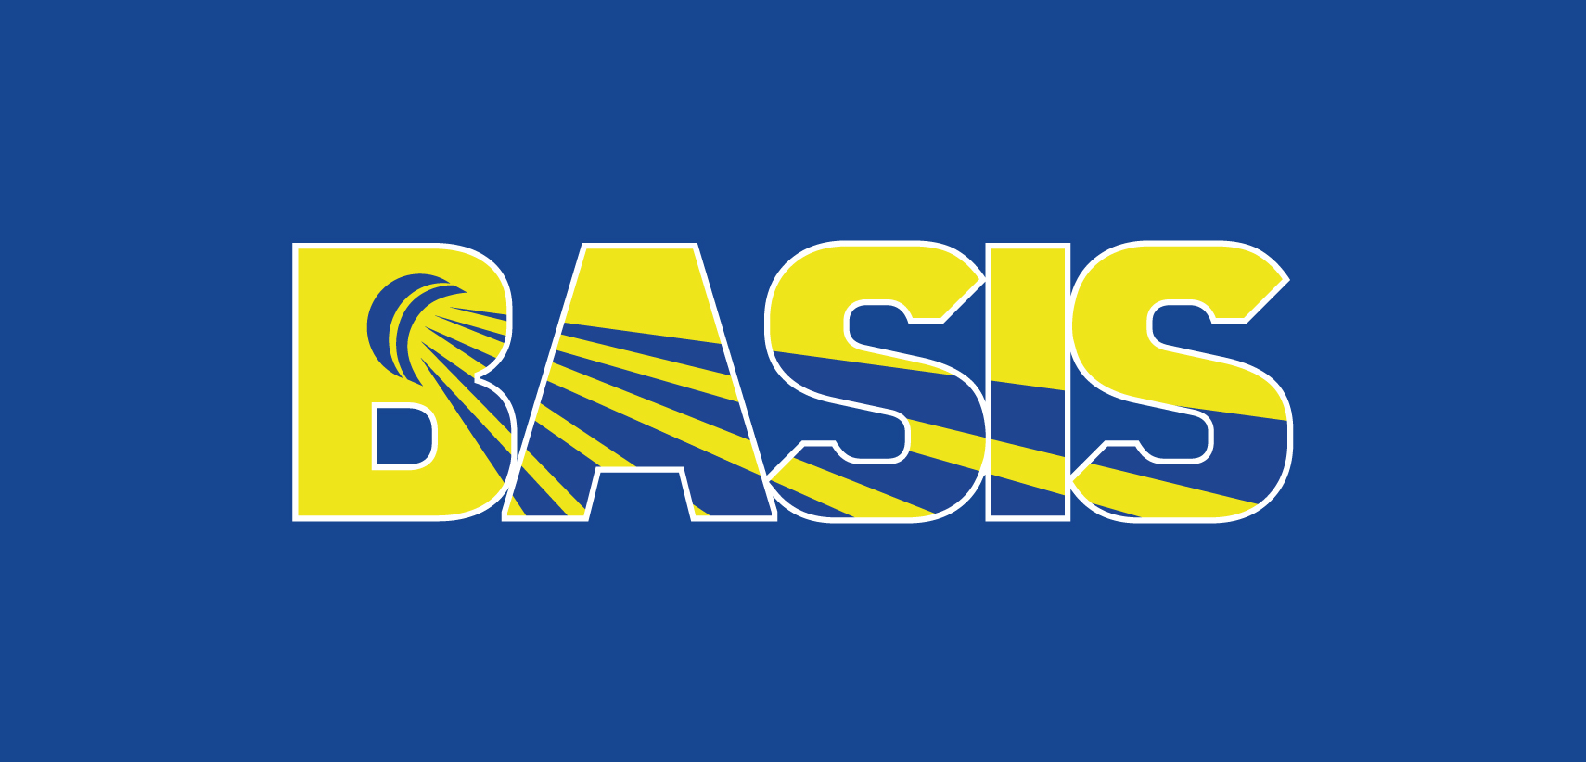
2020 BEC BASIS MEMBERSHIP EXCHANGE PROGRAMME APPLICATION FORM - TO PARTICIPATE

Member Association

Contact Person

Email of contact person

Mobile number of contact person

Participant 1 | Name:  Role in the federation:  Email address:
Participant 2 | Name:  Role in the federation:  Email address:

Please send the application form to Tania Teoh, BEC Development and High Performance Manager at tania.teoh@badmintoneurope.com before Monday, 4th May 2020.

If you have enquiries on the Membership Exchange Programme (MEP), please feel free to contact Tania Teoh, BEC Development and High Performance Manager at tania.teoh@badmintoneurope.com.

